 a screenshot of the script and the result of executing /template/form.html.php.

|  |
| --- |
| a screenshot of the script and the result of executing /homework/name4.php. |

s a screenshot of the new result of executing test.php.

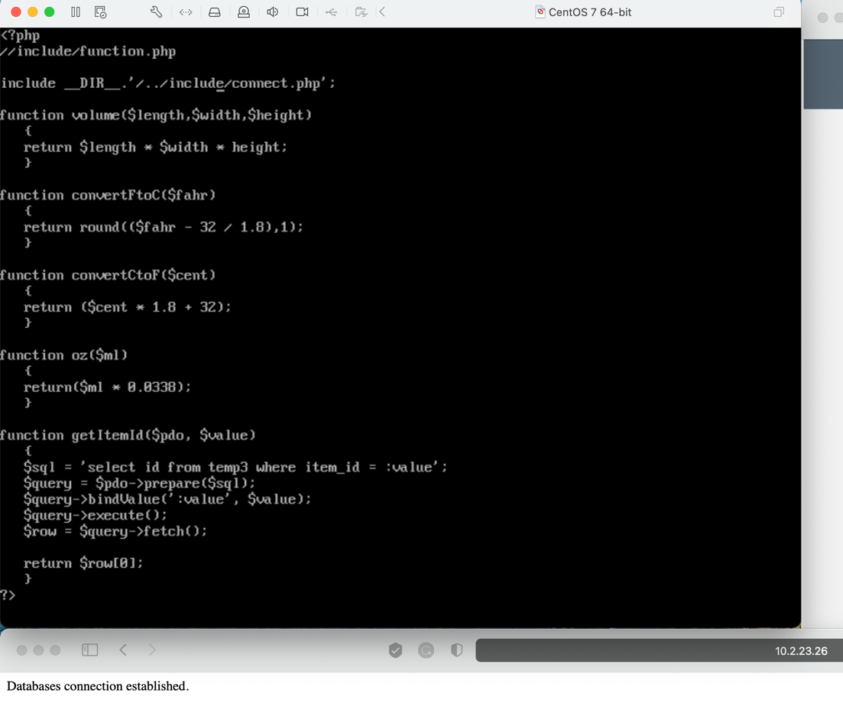 f

their function and the result of finding the id for Red.

